Lab Number: 4

Title: Exploring WSL: Ubuntu CLI Fundamentals and Command-Line Arguments in C

Objective: To become familiar with the Windows Subsystem for Linux (WSL) and Ubuntu command-line environment, to practice fundamental Linux commands for navigation and file handling, and to write, compile, and run simple C programs from the command line, including passing values via user input.

Command Used: Windows CLI Commands/ Linux (Ubuntu WSL) Commands
IDE/Platform: Command Prompt (Windows) and Ubuntu terminal via Windows Subsystem for Linux (WSL)
Theory:
Windows Subsystem for Linux (WSL) lets you run a Linux distribution, such as Ubuntu, directly on a Windows machine giving you a full Linux command-line environment without setting up a separate virtual machine or dual-boot system.
The Command Line Interface (CLI) is a way of interacting with the operating system by typing text commands, rather than clicking through menus and icons in a Graphical User Interface (GUI).
The CLI has several advantages over the GUI: it executes repetitive tasks faster, uses fewer system resources, supports automation through scripts, offers more precise control over the system, and makes remote access over a network more straightforward. GUIs, by contrast, are more visual and beginner-friendly, but tend to be slower for advanced or repetitive operations.
Brief descriptions of commands used:
cd ~/ – Changes directory to the home directory (root of the current user's space).
pwd – Print Working Directory; displays the full path of the current directory.
\wsl$ – Network path used in Windows File Explorer to access the Linux (Ubuntu) file system installed under WSL.
touch – Creates a new, empty file if it does not already exist.
nano – Opens a simple terminal-based text editor used to write or edit a file's contents.
gcc – GNU C Compiler; compiles a C source file into an executable. The -o flag specifies the output/executable file name.
./ – Runs an executable file from the current directory (e.g., ./ss executes the file named ss).
Experimentation
Question 1. Navigate the Ubuntu (WSL) file system and identify the current working directory.

Command:
cd ~/
pwd

Command Action:
The command 'cd ~/' changes the current directory to the home directory (root of the user's own space), and 'pwd' (print working directory) displays the full path of the current directory, which was confirmed to be /home/roger.
The Ubuntu file system installed under WSL can also be accessed directly from Windows File Explorer using the network path \\wsl$, where the Ubuntu distribution appears as a folder.
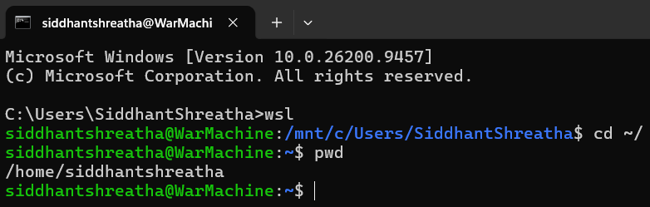
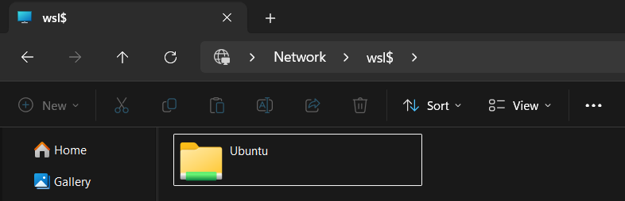

Question 2. Write a C program to add two integers and compile/run it from the CLI.
Command:
touch addnumbers.c
nano addnumbers.c
gcc addnumbers.c -o ss
./ss

Program Code (addnumbers.c) integers defined within the program:
#include<stdio.h>
int main(){
int a = 5, b = 10, sum;
sum = a + b;
printf("Sum of two numbers: %d\n", sum);
return 0;
}

Command Action:
The command 'touch' created an empty C source file, 'nano' opened the terminal-based text editor to write the program, 'gcc' compiled the source file into an executable named 'ss', and './ss' executed the compiled program, which printed the sum of the two integers.
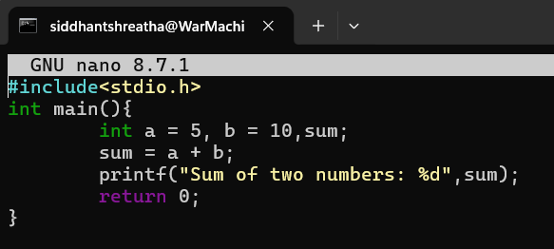
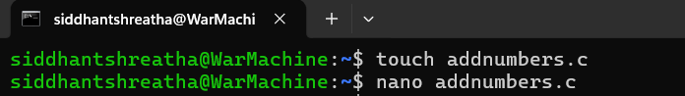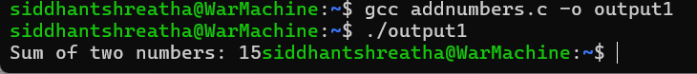
Question 3. Write a C program to add two integers given by the user from the CLI.
Command:
nano addnumbers.c
gcc addnumbers.c -o ss
./ss

Program Code (addnumbers.c) integers entered by the user at runtime:
#include <stdio.h>
int main() {
int a, b, sum;
printf("Enter first number: ");
scanf("%d", &a);
printf("Enter second number: "); scanf("%d", &b);
sum = a + b;
printf("Sum of two numbers: %d\n", sum); return 0;
}

Command Action:
Unlike the previous program where the two integers were hard-coded, this version uses 'scanf' to read the values entered by the user at runtime through the command line, making the program interactive.
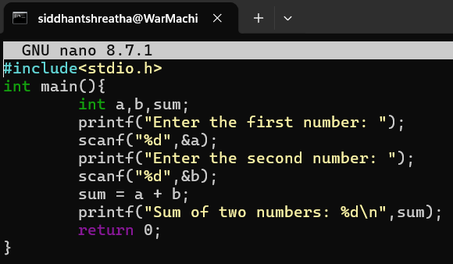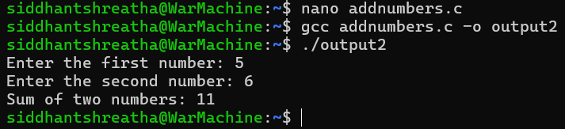
Question 4. Write a C program that accepts command-line arguments and prints argc and argv.
Command:
nano argtest.c
gcc argtest.c -o argtest
./argtest hello world 123
Source Code:
#include <stdio.h>
int main(int argc, char *argv[]) {
int i;
printf("Number of arguments (argc): %d\n", argc);
for (i = 0; i < argc; i++) {
printf("argv[%d]: %s\n", i, argv[i]);
}
return 0;
}
Command Action:
This program accepts command-line arguments, allowing input values to be passed directly when it is run instead of through interactive prompts. It checks argc to ensure the correct number of arguments were supplied and reads their values from argv. If the required arguments are missing, it prints a usage message and exits without crashing. This makes the program easier to test with different inputs and command-line scenarios.

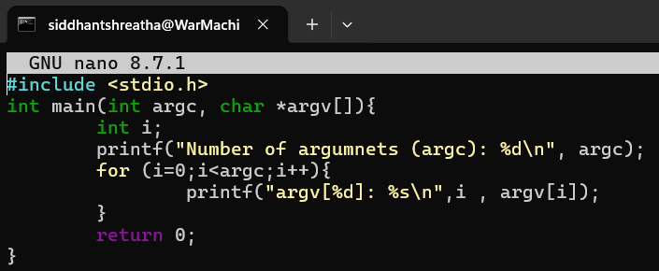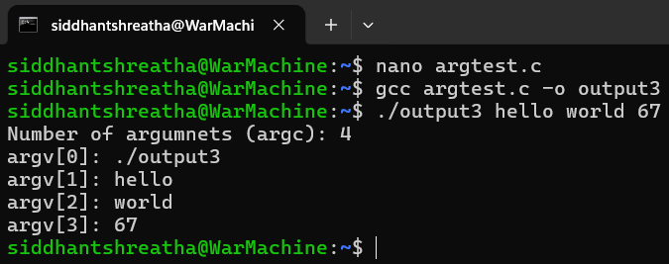

Discussion:
While working with WSL and the Ubuntu CLI, it was observed that the current working directory must always be correct before running a command, otherwise the command will not produce the intended result or will report an error such as 'file not found'. Compiling C programs directly from the terminal using gcc requires specifying an output file name with the -o flag, otherwise the compiler generates a default executable named a.out. Programs that take input from the user (using scanf) are more flexible than programs with hard-coded values, since the same compiled executable can be reused with different inputs each time it is run.
Conclusion:
Hence, we got familiarized with the Windows Subsystem for Linux (WSL) and basic Ubuntu commands such as cd, pwd, touch, and nano for navigating and creating files. We also learned to compile and execute C programs from the command line using gcc, both with hard-coded values and with values supplied interactively by the user.

